Kindergarten Location Unit—Day 1
Enduring Theme: Location
Standards:
- Math: MA 0.2.4 Spatial Modeling
- Visual: FA 2.2.1e
Objectives:
- Students will be able to identify location of objects inside or outside
- Students will be able to demonstrate the proper way to hold scissors and trace a shape
Anticipatory Set:
- Ask students “What would you do if it begins to rain and you are outside Go Inside. “You go inside. Today we are going to learn about inside and outside?”
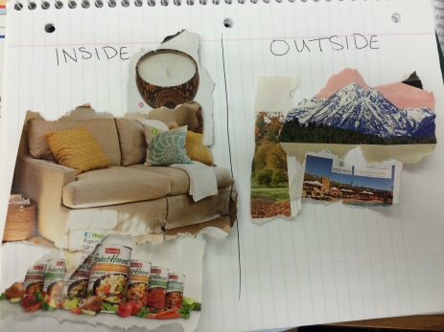
- Hold hands and form a circle. Name please jump inside the circle. Now ask a friend to come in with you. Name, go outside the circle and to your place.
Vocabulary:
- Inside
- Outside
- Unity
- Collage
Information:
- Have students sit in a small area by marker board. Start by explaining what inside and outside mean. Have students brainstorm examples of inside and outside. Divide board in half and write inside and outside at the top. Write the ideas that the students give in the right place.
- Students go back to their seats at table. Pass out paper. Tell them to fold their paper in half. One half they will write inside at the top and draw a picture of their favorite thing to do inside. The other half they will draw their favorite thing to do outside. When done everyone gets to share their drawings with students at their table.
Activity/Assessment:
- Pass out white paper fold in half. Write inside on one half outside on the other. Cut out pictures from magazine of things that belong inside/outside. Glue in collage.

Kindergarten Location Unit—Day 2
Enduring Theme: Location
Standards:
- Math: MA 0.2.4
- Visual Arts: FA 2.2.3a
Objectives:
- Students will be able to identify relative location of objects left and right
- Students will be able to describe which mitten is left\right and explain how they decorated it
Bell work:
- Worksheet from 1-1. Page 1 Houghton Mifflin Mathematics
Anticipatory Set:
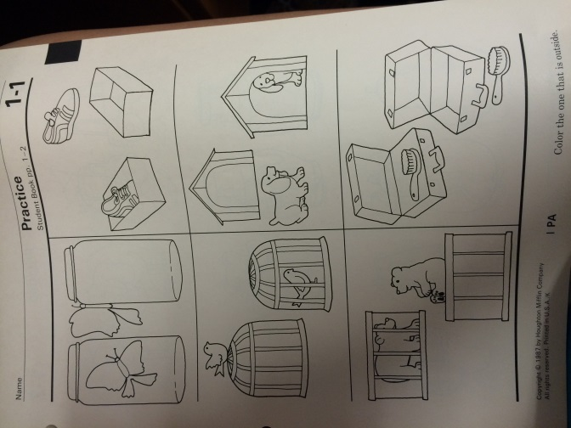
- Hokey Pokey
  - Left\right
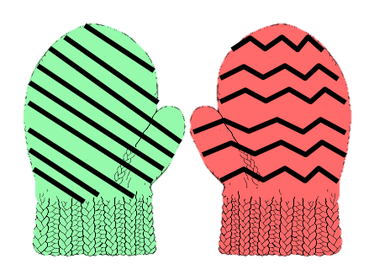
    - Hands
    - Feet
    - Elbows
    - Arms
Vocabulary:
- Left
- Right
- Diagonal line
- Zig-zag line
Information:
- Work on page 3&4 Houghton Mifflin Mathematics
- Using the Pages Textbook
Activity\Assessment:
- Hand out mittens
- Students need to color mittens by instruction. Left mitten: red\diagonal lines. Right mitten: green\zig-zag lines.
- Cut out
- Glue on Black paper
Kindergarten Location Unit—Day 3
Enduring Theme: Location
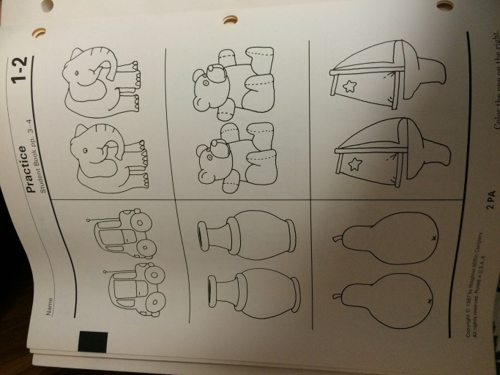
Standards:
- Math: MA 0.2.4
- Visual Arts: FA 2.2.1b
Objectives:
- Students will be able to identify before and after
- Students will be able to identify free-form shape
Bell Work:
- Workbook page 1-2
Anticipatory Set:
- 4 kids will stand at front of room all facing the same way. Ask students who is before so and so. Same goes for after
Vocabulary:
- Before
- After
- Free-form shape
Information:
- Using pages teacher textbook Houghton Mifflin Mathematics pages 5&6
- Worksheet pages 5&6
Assessment:
- Draw picture of what you would wear before you go outside in winter.
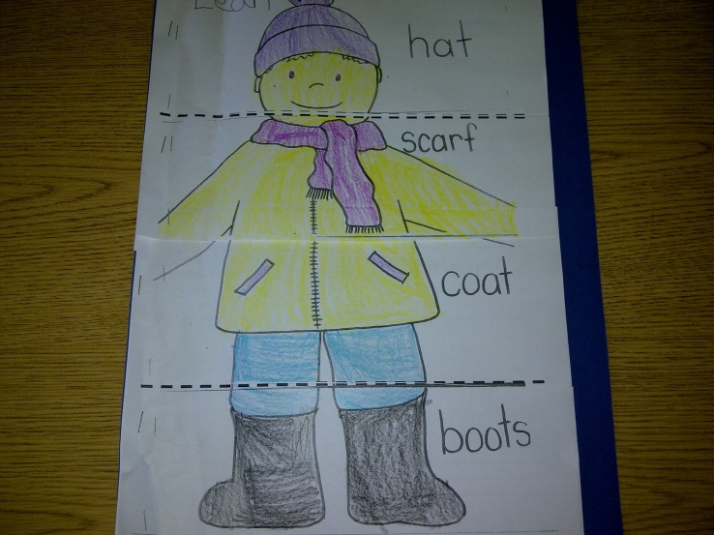

Kindergarten Location Unit—Day 4
Enduring Theme: Location
Standards:
- Math: MA 0.2.1
- Visual Arts: FA 2.2.1e
Objectives:
- Students will be able to identify objectives between
- Students will be able to identify circles and squares
Anticipatory Set:
- Review before and after page 1-3
Vocabulary:
- Between
- Circle
- square
Information:
- Refer to Houghton Mifflin Mathematics Textbook using pages worksheet page 7&8
- How to make sandwiches. What do you use to make?
Assessment:
- Draw sandwich out of circles & squares
  - 1 circle between 2 squares (grilled cheese, pbj)
  - 1 square between 2 circles (hamburgers)
- Color
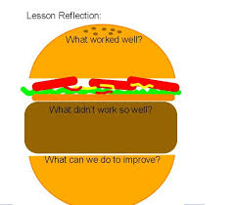

Kindergarten Location Unit—Day 5
Enduring Theme- Location
Standards:
- Math: MA 0.2.4 Spatial Modeling
- Visual Arts: FA 2.2.2b
Objectives:
- Identify location of objects nearest and farthest
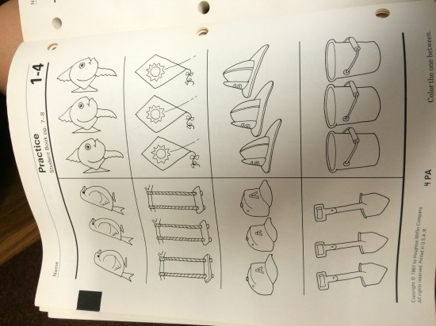
- Identify depth and light/dark colors
Bell Work:
- Practice 1-4
Vocabulary:
- Nearest
- Farthest
- Light colors
- Dark colors
Information:
- Teacher’s Edition Level K, Houghton Mifflin Mathematics page 10. Using the Pages to go with page 9 and 10 of workbook
Assessment:
- Pass out plain paper and talk about depth.
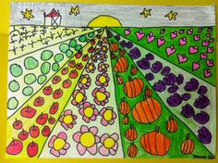
- Have kids draw lines to one point in middle\top
- Kids can draw background and sun
- Draw in rows of vegetables
- Color

